**User Manual**

**Setting up the Libraries**

1. Download both editorApp.jar and talkboxApp.jar
2. Download JavaFX libraries to a folder from the link below: <https://gluonhq.com/products/javafx/>
3. Download the freetts .jar file from the link:  
   [central.maven.org/maven2/net/sf/sociaal/freetts/1.2.2/freetts-1.2.2.jar](http://central.maven.org/maven2/net/sf/sociaal/freetts/1.2.2/freetts-1.2.2.jar)
4. Save the freetts.jar file **inside** the lib directory of your javafx download, the path should look something like this:

*\..\javafx-sdk-11.0.2\lib*  
 Where the ‘..’ is the file where you saved the library.

Remember these file paths as they will be needed later.  
  
**Running the editorApp.jar**

1. Open the terminal or CMD and navigate to the file where the editorApp.jar and talkboxApp.jar are located.
2. If you are using **Windows**, issue the command:  
   *java -jar --module-path "..\javafx-sdk-11.0.2\lib" --add-modules=javafx.controls,javafx.graphics,javafx.media,javafx.fxml editorApp.jar*

If you are using **Linux or Mac**, issue the command:

*java -jar --module-path /../javafx-sdk-11.0.1/lib --add-modules=javafx.controls,javafx.graphics,javafx.media,javafx.fxml editorApp.jar*

**NOTE: Fill in the ‘..’ with the actual path of where you saved javaFX from step 2**

1. This will load the main Editor app and should look like the following image: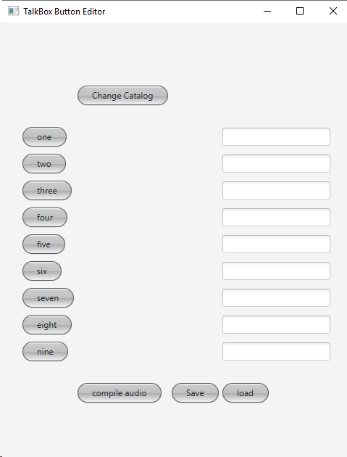
2. You must click the “compile audio” button as this will generate the audio buttons. The audio files will be generated in the root directory of where the .jar files were downloaded in step 1.
3. You must then click the “Save” button first. This serializes the current buttons so the talkboxApp can load them. The serialized file is generated in the root directory of where the .jar files were downloaded in step 1.
4. To edit any of the buttons, type out a word in its corresponding text field to the right **AND** click the text field. Clicking the text field saves what is currently in it.
5. Once you are done editing, repeat steps 8 and 9 to compile audio and save the current object state.

**Running the talkboxApp.jar**

1. To run the front end talkboxApp.jar you must issue the following commands  
   **NOTE**: Fill in the ‘..’ with the actual path of where you saved javaFX from step 2.

If you are using **Windows** issue the command:  
*java -jar --module-path "..\javafx-sdk-11.0.2\lib" --add-modules=javafx.controls,javafx.graphics,javafx.media,javafx.fxml talkboxApp.jar*

If you are using **Linux or Mac** issue the command:

*java -jar --module-path /../javafx-sdk-11.0.1/lib --add-modules=javafx.controls,javafx.graphics,javafx.media,javafx.fxml talkboxApp.jar*

The main talkboxApp will look like the image shown below:

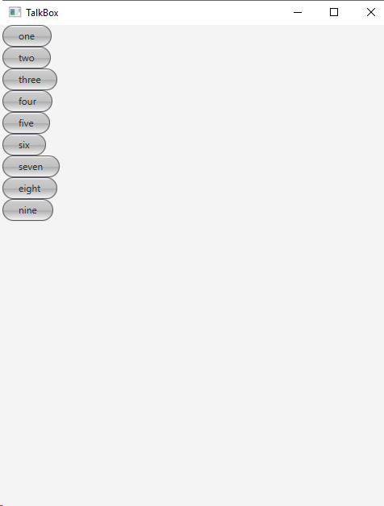

**NOTE:** if no serial file is available, you will get an error, make sure step 8 was completed in the editorApp. If audio is not playing, ensure you did step 9 in the editor app.